Change wifi to MYADPWIFI need to switch back to ADPESWLAN after plugins are added n tested

Plugin for Code quality check

Step2->Need to switch network Direct as below

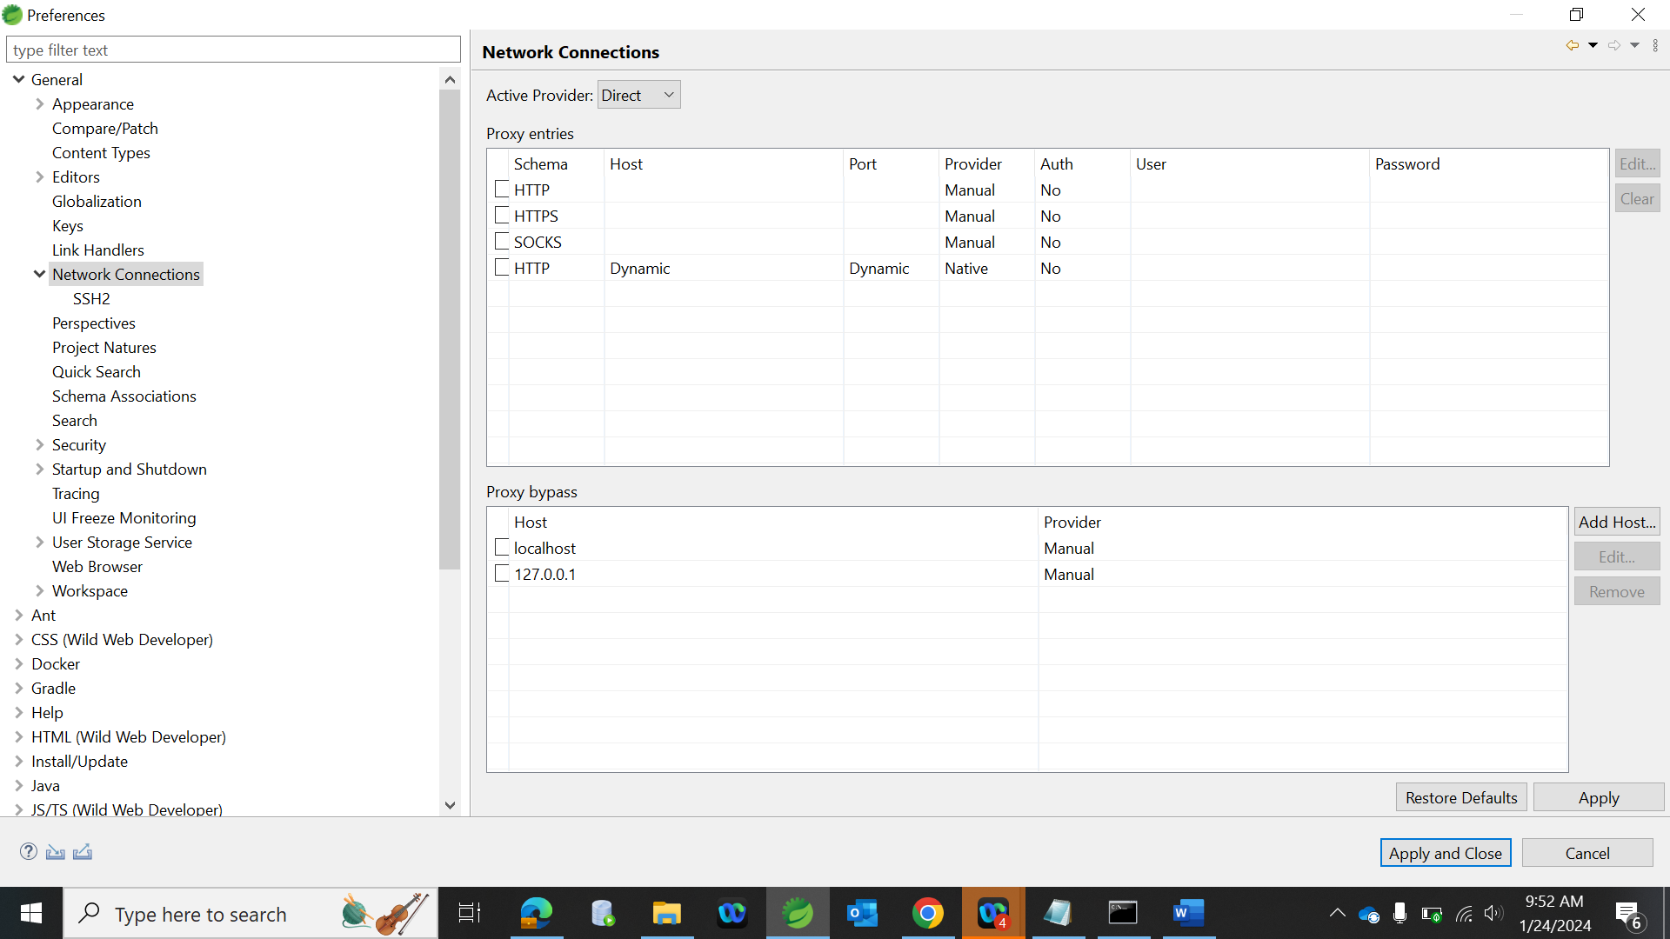

General->NetworkConnections->Active Provider->Direct.

Step3-> in STS – goto Help -> EclipseMarketPlace- > search for plugin SonarLint/PMD select and install.

Plugin for Code Covergae

Help -> EclipseMarketPlace- > search for plugin Jacoco select and install.

STS will ask for restart you can restart.uality

Step3-> Right click on any project check for -> SonarLint for quality code suggestions.

Step4-> Right click on any test package -> CoverageAS for test coverage percentage.

At the end don’t forget to switch back Wifi.